The below Proposal template is only for information and will be subject to change.
The proposal will be submitted as part of a Call for Proposal without Procurement on esastar resulting in a Cooperative Agreement in case of selection.

DETAILED PROPOSAL

[N.B. Use this template to prepare your Proposal. Once the Proposal is complete and internally validated, please remove all captions in red colour, delete all ESA headers/footers, add your own logos, headers/footers prior to finalising your Proposal for submission to ESA. The Proposal shall be submitted in a searchable and indexed PDF file for easier viewing.
When submitting to esa-star Tendering, separate this template according to the required Proposal elements/parts and upload those individual elements/parts accordingly.]

[DETAILED PROPOSAL]

DETAILED PROPOSAL

- BACKGROUND AND FACILITIES

  - Background of the company(ies)

……………
[Present the participating company(ies) and briefly describe relevant experience for the Partner and Subcontractor(s), if any, for the performance of the work.]

  - Technical achievements relevant to the activity and/or to be used

……………
[Detail any achievements for the Partner and Subcontractor(s), if any, which are relevant to their experience for the performance of the work.]

  - Overall Team composition, Proposed Key Personnel

……………
[Please describe the overall team composition, including the subcontractors and external suppliers, if any, and provide information on the relevant background of the proposed Key Personnel (see definition of Key Person below) for the work to be performed.

NOTE: A “Key Person” is a person working for either the Partner or a Subcontractor, who substantially contributes, in terms of effort and knowledge, to the work carried out under a Cooperative Aggreement and who is explicitly nominated to perform such duties. Key Persons are individuals with a certain degree of seniority whose knowledge, reputation and/or skills in the relevant areas or disciplines are critical to achieving the objectives of the Cooperative Agreement. Consequently, Key Persons have a major role within the team and only Key Persons can be responsible for one or more Work Packages. At least one Key Person must belong to the Partner.]

  - Curricula Vitae of Key Personnel

……………
[Concise CVs including relevant information for all Key Personnel shall be submitted in the designated ‘Curricula Vitae’ folder in esa-star, separately from this document. Provide here a list of the CVs uploaded in esa-star.]

- TECHNICAL PART

  - Understanding of the main technical objectives of the CFP

……………
[Tenderers shall provide an introduction showing the understanding of the technical requirements and objectives]

  - Proposed approach to reach the main technical objectives of the CFP

……………
[Tenderers shall justify the proposed approach to reach the main technical objectives of the CFP.]

  - Technical Reservations – Technical Compliance

    - Reservations

……………

  - Existing own concepts/products to be used (Partner and Subcontractors)

……………
[Please indicate any own concepts/products you wish to use to execute the work, detailing them from a technical point of view in this section. If such items are to be embedded in any of the deliverables, or must be delivered to the Agency, they must also be identified in the Background Intellectual Property table in the Administrative part of your Detailed Proposal. Please also note the following:
- The use of any own concepts/products for the development of the deliverables under the resulting Agreement will require the explicit prior written approval by the Agency.]

  - Third Party’s concepts/products (outside of the consortium which is composed by the Partner and Subcontractor/s) intended to be used

……………
[Please indicate any Third Party concepts/products you wish to use to execute the work, detailing them from a technical point of view in this section. If such items are to be embedded in any of the deliverables, or must be delivered to the Agency, they must also be identified in the Background Intellectual Property table in the Contractual part of your Detailed Proposal. Please also note the following:
- The use of any Third Party(ies) product for the development of the deliverables under the resulting Agreement needs the explicit prior written approval by the Agency.
- It shall be the obligation of the Tenderer to verify and confirm in writing to the Agency that the licence, under which a Third Party(ies) product shall be licensed to the Agency, grants the Agency at least the same, but non-exclusive perpetual usage, distribution and exploitation rights.
- If the Tenderer is allowed to do so, the Tenderer shall provide and licence, based on a separate licence agreement with the Agency, to the Agency a complete copy of the original Third Party(ies) product.
- Please note that Third Party products distributed under open-source licences, must be indicated here and in the Contractual part your Detailed Proposal.]

  - Potential Problem Areas

    - Identification of the main problem(s) or problem area(s) likely to be encountered in performing the activity

……………
[In this section, Tenderers shall identify potential technical problems and challenges.]

    - Proposed solutions to the problems identified

……………
[In this section, Tenderers shall identify possible solutions and/or mitigation strategies for the problem areas identified above.]

    - Proposed trade-off analyses and identification of possible limitations or non-compliances

……………
[In this section, Tenderers shall identify possible trade-offs, limitations and non-compliances related to the problem areas identified above.]

  - Technical Implementation/Programme of Work

    - Proposed Work Logic

……………
[In the form of a flow chart with networks and critical path.]

    - Contents of the proposed work

      - Work Breakdown Structure (“WBS”)

……………
[For the total scope of the activity, clearly showing each foreseen Work Package (“WP”) with its title and the name of the responsible company/institute.]

      - Work Package Description (“WPD”)

……………
[For each WP already shown in the WBS: WP Title, Name of responsible company/institute, Name of the WP Manager (has to be one of the Key Personnel), Input required to start the work under the WP, Output expected and a description of the tasks included in the WP. Please use the ESA PSS A20 form or an equivalent template, available at https://esastar-publication.sso.esa.int/supportingDocumentation.]

  - Deliverable Items – Specification of any Non-Conformance

    - Deliverable Items

……………
[State your acceptance to deliver all required items as per the Statement of Work and in the Draft Agreement (Article 2) included in the CFP (as Appendices 1 and 2, respectively). You do not need to submit a Deliverable Items List (DIL) but only state your acceptance to the delivery of all the Documents and other Items listed in the Statement of Work. All deliverable items must be identified as output in one of the Work Packages. If you have non-conformance, limitation or additions, please indicate them in the next section.]

    - Non-conformances/limitations/additions regarding deliverable items

……………
[In case you propose any limitation(s) or even any deletion(s) when compared with the CFP requirements on deliveries, specify it in this section by providing a complete and comprehensive list of such differences, by stating the reason(s) associated with the proposed limitation(s) or deletion(s). If you envisage addition(s), specify any additional deliverable(s) proposed.]

  - Planning

    - Proposed schedule and milestones

……………
[Synthetic summary of duration, planning assumptions (e.g., envisaged starting date, holidays, etc.), meetings/videoconferences and major technical milestones.]

    - Bar chart

……………
[Insert a bar chart schedule for the proposed activity, covering from the start of the activity until the end of the Agreement, where all proposed Work Packages, meetings, milestones, etc. can be traced, also indicating (e.g., via colour code) the entity that is in charge of a given WP. The bar chart shall be provided in a readable (landscape) format. Please use a T+X months format from your proposed KO date for the time axis (e.g., T0+1 month).]

- MANAGEMENT PART

  - Team Organisation: Reporting lines within the team and communication lines with ESA

……………
[ Present the management plan for this activity indicating the reporting lines within your team (including subcontractors) in the form of a diagram. The diagram must include all Key Personnel as a minimum and also show WPs. An example diagram is given here below. Please also include a communication line to ESA in the diagram.]

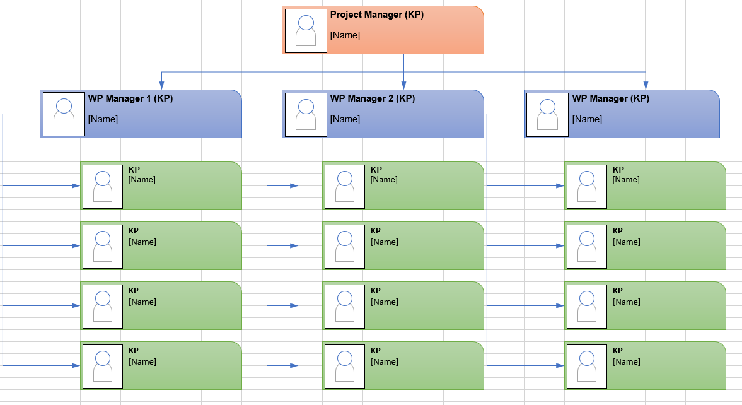

  - Time dedication of the Key Personnel

……………
[For each Key Personnel identified in section 1.3 above, provide a summary of the hours dedicated to each WP as well as their time dedication (i.e., the percentage of their total working time to be dedicated to the envisaged Agreement in average over its total duration of the work). The table shall also provide one row showing the allocation of man-hours per Work Package for all non-Key Personnel together.]

Key personnel | Role in the activity | WP… | WP… | WP… | WP… | TOTAL | Percentage time dedication (Time of activity/Total working time)
[insert name] | [insert role, e.g., Project Manager, QA Engineer) name]1 |  |  |  |  |  | [insert percentage time dedication, e.g., 25%]
[insert name] | [insert role, e.g., Project Manager, QA Engineer) name]1 |  |  |  |  |  | [insert percentage time dedication, e.g., 25%]
Non-Key Personnel
…
…
…
TOTAL

